Project : Capstone I
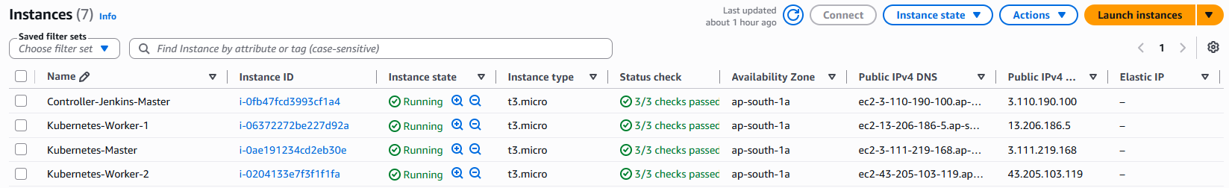
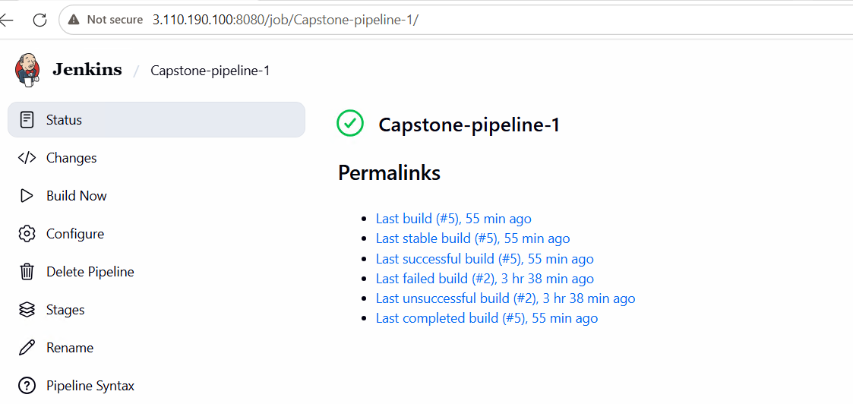
pipeline {
agent any

stages {
// JOB 1: Automated Infrastructure Build Sequence
stage('Job1: Build') {
steps {
echo '=== STARTING PHASE 1: CONTAINER GENERATION ==='
// Pulls the code directly into Jenkins workspace automatically
git branch: 'master', url: 'https://github.com/hshar/website.git'

// Clean multi-line echo that writes the Dockerfile exactly as required
sh '''
echo "FROM hshar/webapp:latest" > Dockerfile
echo "COPY . /var/www/html/" >> Dockerfile
echo "EXPOSE 80" >> Dockerfile
echo "CMD [\\"apache2ctl\\", \\"-D\\", \\"FOREGROUND\\"]" >> Dockerfile
'''

// Compiles the application container artifact layers
sh 'docker build -t capstone-app:${BUILD_NUMBER} .'
}
}

// JOB 2: Automated Testing Lifecycle Matrix
stage('Job2: Test') {
steps {
echo '=== STARTING PHASE 2: QA REGRESSION LIFECYCLE ==='
sh 'echo "Running integration checks... Complete!"'
}
}

// JOB 3: Production Gate Control Layer
stage('Job3: Prod Release') {
steps {
echo '=== STARTING PHASE 3: PROD ARTIFACT ROTATION ==='
// Rotates any old active web containers to clear up port 80
sh 'docker rm -f live-web-production || true'
sh 'docker run -d --name live-web-production -p 80:80 capstone-app:${BUILD_NUMBER}'
echo 'Successfully deployed to Production Environment!'
}
}
}
}

